

**NETWORKING & SYSTEM ADMINISTRATION LAB**

**Experiment No.: 6**

**Aim**

Familiarization of linux commands

**Procedure**

1. **read**

**read command** in Linux system is used to read from a file descriptor. Basically, this command read up the total number of bytes from the specified file descriptor into the buffer. If the number or count is zero then this command may detect the errors.

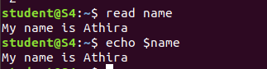

1. **locate**

*locate* command in Linux is used to find the files by name. There is two most widely used file searching utilities accessible to users are called find and *locate*. The *locate* utility works better and faster than *find* command counterpart because instead of searching the file system when a file search is initiated, it would look through a database. This database contains bits and parts of files and their corresponding paths on your system.





**option**

**locate -i**

–ignore-case : Ignore case distinctions when matching patterns.





1. **find**

The **find** command in UNIX is a command line utility for walking a file hierarchy. It can be used to find files and directories and perform subsequent operations on them. It supports searching by file, folder, name, creation date, modification date, owner and permissions.



1. **grep**

The grep filter searches a file for a particular pattern of characters, and displays all lines that contain that pattern. The pattern that is searched in the file is referred to as the regular expression

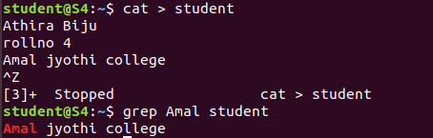

**Options:**

**grep -A1**

**-A n** **:** Prints searched line and nlines after the result.



**grep -B1**

**-B n :** Prints searched line and n line before the result.

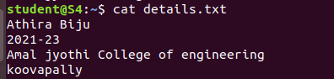



**grep c1**

-C n : Prints searched line and n lines after before the result.



**grep -i**

**-i :** Ignores, case for matching



**grep -v**

-v : This prints out all the lines that do not matches the pattern

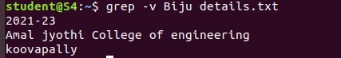

1. **df**

The df command (short for disk free), is used to display information related to file systems about total space and available space.

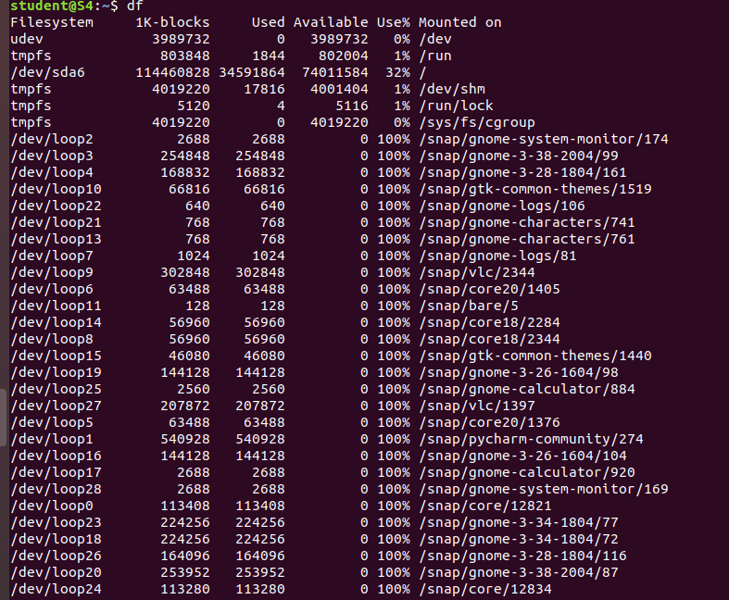

Options:

df -m

displays the amount of disk space available on the file system.

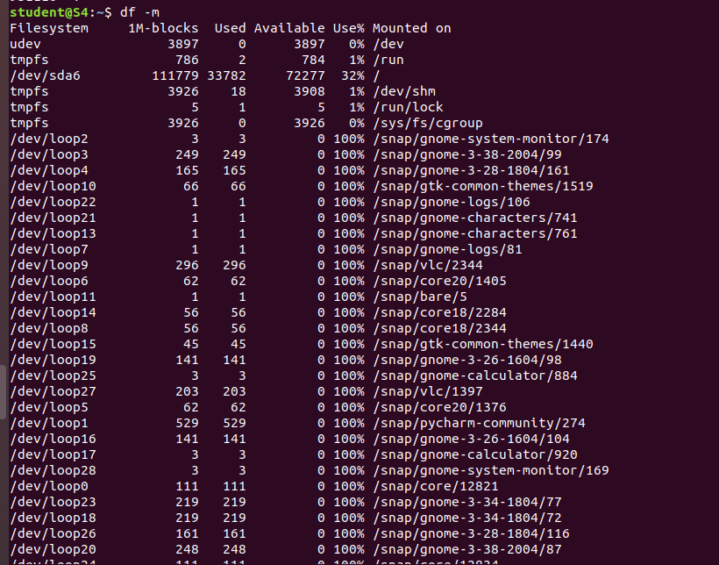

1. **du**

du command ,short for disk usage, is used to estimate file space usage.the du command can be used to track the files and directories which are consuming excessive amount of space on hard

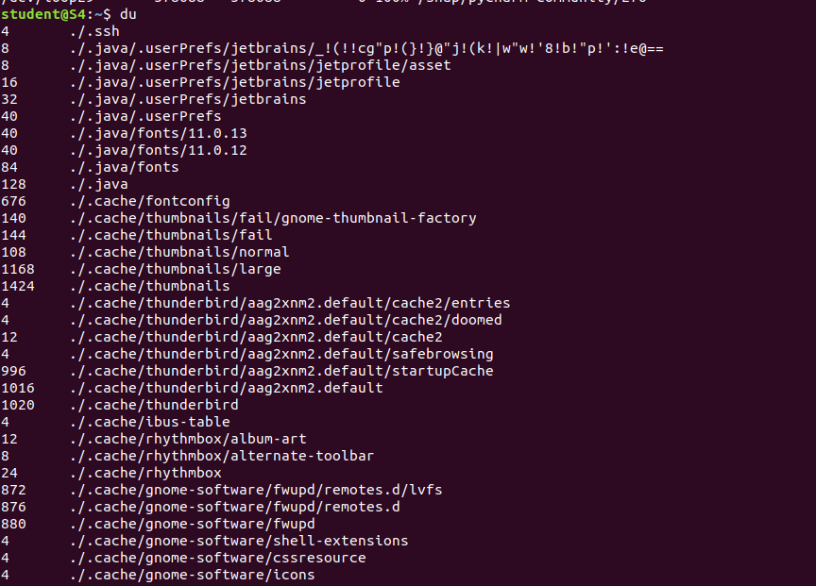

1. wc

Linux wc command helps in counting the lines, words, and characters in a file. It displays the number of lines, number of characters, and the number of words in a file. Mostly, it is used with pipes for counting operation.

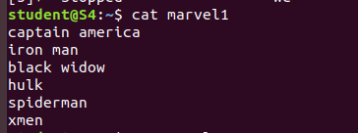



**Options**

wc -c

It is used to print the byte counts.



wc -l

It is used to print the newline counts.



wc -m

It is used to print the character counts.



wc -w

It is used to print the word counts.

